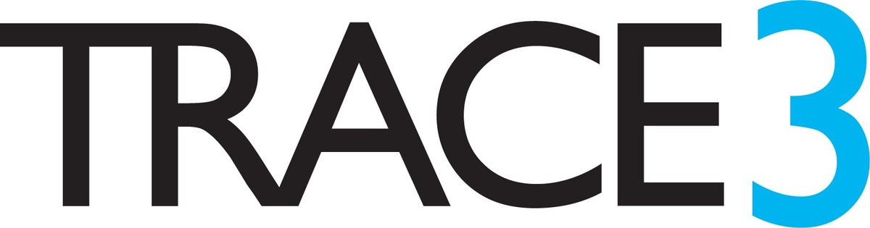 Meeting Management Tool

BUDT748 Industry Practicum - Group 1

Dashboard Screenshots for UMD Smith Prototype

1. Projects

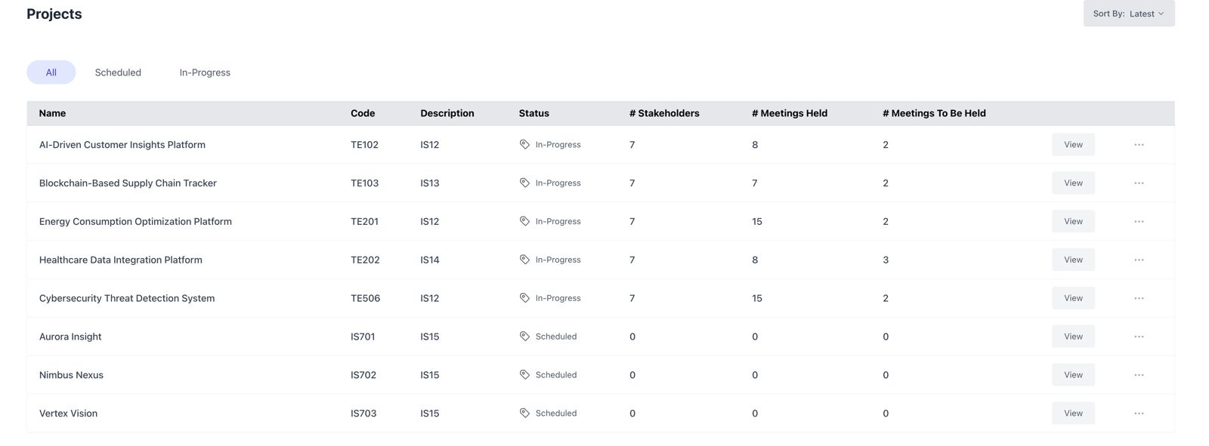

1. Stakeholders

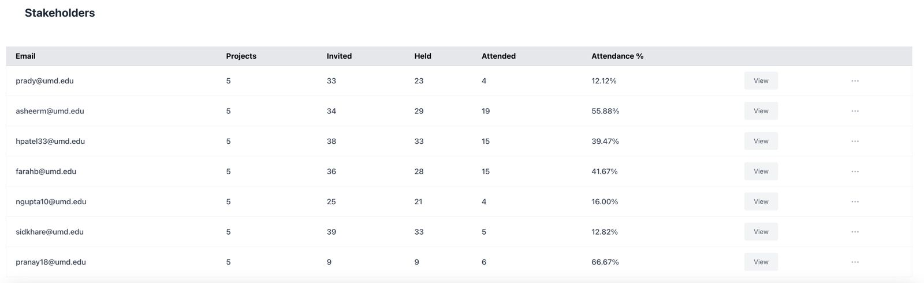

1. Upcoming Project Meetings

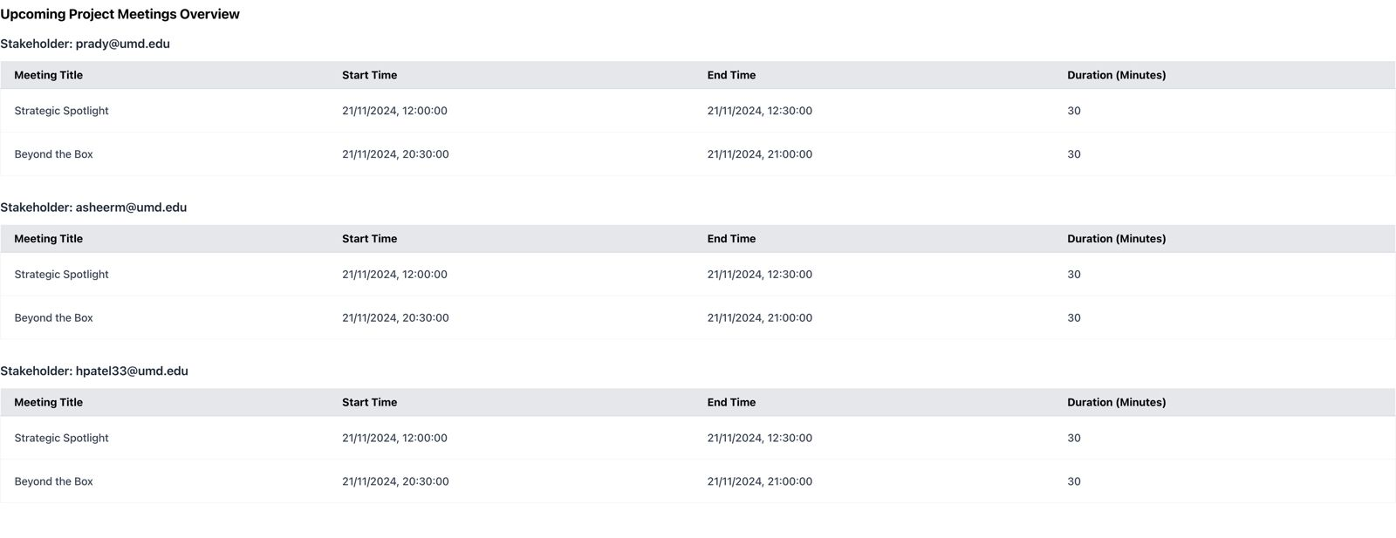

1. Project-wise Overview for Stakehodler

